# Chapter 6

## Other Project issues

### 6.1 Risk Management

While doing this project I haves faces many problem and by tackling them I have move ahead. Risk may be arise from anywhere and anytime. Managing this risk is tough challenge for programmer. The risk I have faced while completing this project are mentioned below:

**Impact = Likelihood * Consequence**

Risk Likelihood values are shown as follows

|  |  |
| --- | --- |
| **Likelihood** | **Value** |
| Low | 1 |
| Medium | 2 |
| High | 3 |

Risk Consequence values are shown below

|  |  |
| --- | --- |
| **Consequence** | **Value** |
| Very low | 1 |
| Low | 2 |
| Medium | 3 |
| High | 4 |
| Very High | 5 |

Risk Consequence values are shown below

|  |  |  |  |  |  |
| --- | --- | --- | --- | --- | --- |
| **S. NO.** | **Risks** | Likelihood | Consequences | Impact | **Solution** |
| 1 | Network system down | 2 | 3 | 6 | While doing this project I have face the problem of internet so that I have change the ISP Services and could not face the problem of Network System Down. |
| 2 | Not backing up the coding files | 2 | 4 | 8 | I have forgotten to take the back up of coding files time to time so to overcome this problem I have GIT hub version controller to recover my files. |
| 3 | Hard drive crashes | 2 | 3 | 6 | While Doing this project my hard drive has been crashed. Before crashing I have taken backup of project files and uploaded it to google drive so that I can recover it. |
| 4 | Not planned resources | 1 | 1 | 1 | Before doing this project there is not managed any resources to complete this project. I have managed project whatever available resources I have found for this project. |
| 5 | No advanced technology available or the existing technology is in initial stages. | 2 | 2 | 4 | In this project there no any advanced tool has been used. I have done this project what tools I have available. |

### 6.2 Configuration Management

The process of maintaining computer system and software in the automated method in a consistent state is known configuration management. If there is no configuration management is maintain in a automation system or large scale IT system then there will be the chances of increasing risk due to manual error. The main advantages of configuration management is maintaining consistency system. The configuration management for my project is mentioned below:

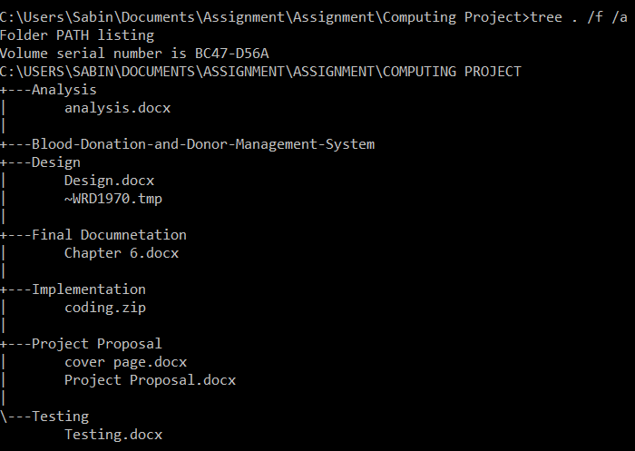

### 6.3 Project Issues

Project issues are the problem which give error while perform the project. This issues makes so many errors in the project. In my project also I have faced so many problem which makes so many error in my project. The issues I have faced in my project is syntax error which makes my application in not workable. Sometimes I have faced the problem of server down from my local host which I have solved by restarting the server. There is problem from the interface. Interface might not at correct place. Sometimes div error will occur. This error in caused due to the width and height and position in CSS I have create in my application. This all problem have been solved by correcting the div size with the body and all position is corrected by adjusting the length required.

Other project issues I have faced while doing this project is electricity problem from Nepal Electricity Authority. Due to heavy rainfall, there is the problem of electricity in my locality. To overcome this problem I have used alternative power supply for my project. There is problem in my system due to excessive use of the system. Also my IDE license also expired while doing this project. Also there in problem while I am testing my application. While testing the application due to slow performance of my system I have to wait for a bit of time. While testing, I have problem in login testing. PHP laravel tested the auto generate login form but in my application I have used custom login form. Also I have problem on preventive the user to login in user dashboard. Which means I have forgotten to use authentication. It means system will not secured from user also. So at least have inserted guard for my system.

### 6.4 Limitation

A limitation is a restriction executed by the application of (mostly traditional) Project Management. Limitations differ from disadvantages as the latter are undesired results stemming from the adoption/application of Project Management, while limitations are boundaries artificially created by Project Management. There might be also some limitation on my project which are mentioned below:

* This is web based application so it cannot used without internet.
* This application cannot be used until user get internet connection.
* This is web based application so it will required sever also.
* In this application data are less protected because there no SSL enforcement to secure HTTP.
* Security concerns about sensitive private data being transmitted over the Internet.
* This application will run at a slightly slower speed than one hosted on a server locally.
* Unfortunately, we don’t all use the same browser. This means during development you’ll need to ensure your app is supported across a variety of browsers.

### 6.5 Future Works

Future works means adding feature in the future as an update version so that user also might also feel too easy to use. I have also some future plans for this project. After completing the Blood Donor and Donation Management system there are some work left to do. Many requirement is not complete yet. The work that are left to complete are mentioned below:

* User detail can be hidden functions.
* Message Queries send to admin has read or pending function.
* User details can be edit or removed by user function.
* In future development, mobile app for Blood Donor and Donation management system will be developed.

### 6.6 Conclusion

After all the step I have performed above, at last I conclude my project. After completing this project I have mentioned risk that arise while doing this project. Risk may arise or may not be arise but we have to prepare for the risk. So that I also have prepared for the risk likewise I have mention in above risk management what risk I have faced while doing this project. Also I have provide the conclusion to do this project. Also I have some project issues occurred while doing this project. And I have mentioned that issues in above. There are some limitation also in my project and this also mentioned above paragraph. There are some works left to complete in the time so I have mention those work in future works so that I could use that feature as future works. Finally, I have completed my project by performing all the steps as mentioned above.

Finally, project is complete by performing all the steps. This is the last concluded part of this project. I have complete all the phase required for this project. Like Requirement analysis, design, implementation, testing, documentation. I have water fall model to complete this project. At first, all requirement has been fulfilled in the analysis phase of this methodology. After then, in design phase all required diagram has been designed which includes class diagram, activity diagram as well as sequence diagram. After completing the design phase, implementation phase will come and in this phase all coding part will be done and in this phase define the MVC pattern of this project. After completing this phase, we proceeds for testing phase and in this phase all the code will be tested. Finally the project ready to release and at last the final documentation will be made. This how my whole project is completed.